**NAME: TEMIDAYO OLUWARANTIMI BLESSING**

**STUDENT ID: IDEAS/24/51291**

INT303: Networking Fundamentals – Lab 1

# Lab 1: Understanding Network Layers and TCP/IP Model using OWASP Broken Web Application IP

## Exercise 1: Understanding OSI and TCP/IP Models

**Question:**

**List the OSI model layers and describe the function of each.**

The **OSI (Open Systems Interconnection) model** is a framework used to understand how different networking protocols interact in a communication system. It consists of seven distinct layers, each with its specific function. These layers are:

**1. Physical Layer (Layer 1)**

* **Function**: The Physical Layer is responsible for the transmission and reception of raw data bits over a physical medium (such as electrical signals, light pulses, or radio waves). The external port on a device. Examples: Ethernet cables, fiber optic cables, wireless signals (Wi-Fi), and network hubs.

**2. Data Link Layer (Layer 2)**

* **Function**: The Data Link Layer is responsible for node-to-node data transfer, error detection and correction, and framing. It ensures that data sent over the physical layer is correctly formatted for transmission and received without errors. (point–to–point connection). Examples: Ethernet, Wi-Fi (IEEE 802.11), PPP (Point-to-Point Protocol), and switches.

**3. Network Layer (Layer 3)**

* **Function**: The Network Layer is responsible for routing data across networks. It determines the best path for data to travel from the source to the destination across different networks and subnets. Examples: IP (Internet Protocol), IPv4, IPv6, routers, and ICMP (Internet Control Message Protocol).

**4. Transport Layer (Layer 4)**

* **Function**: The Transport Layer is responsible for end-to-end communication between devices, ensuring that data is transferred reliably and in the correct sequence. It also manages flow control, error correction, and retransmission of lost data. Examples: TCP (Transmission Control Protocol), UDP (User Datagram Protocol), and SCTP (Stream Control Transmission Protocol).

**5. Session Layer (Layer 5)**

* **Function**: The Session Layer is responsible for establishing, managing, and terminating communication sessions between applications. It ensures that data is properly synchronized and organized between different applications running on different devices. Examples: NetBIOS, RPC (Remote Procedure Call), and SMB (Server Message Block).

**6. Presentation Layer (Layer 6)**

* **Function**: The Presentation Layer is responsible for translating, encrypting, and compressing data so that it can be properly understood by the application layer. It ensures data is in the right format for the application, regardless of the underlying system architecture. Examples: SSL/TLS (for encryption), JPEG, GIF, MPEG (for data encoding), and ASCII/Unicode translation.

**7. Application Layer (Layer 7)**

* **Function**: The Application Layer is the topmost layer and is responsible for providing network services directly to end-users or applications. It defines the interface through which applications can interact with the network. Examples: HTTP (Hypertext Transfer Protocol), FTP (File Transfer Protocol), SMTP (Simple Mail Transfer Protocol), DNS (Domain Name System), and POP3 (Post Office Protocol).

**Match each OSI layer with its corresponding TCP/IP layer**

The TCP/IP layer has 4 layers. They are: Link Layer, Internet Layer, Transport Layer, and Application Layer.

|  |  |
| --- | --- |
| OSI LAYER | TCP/IP |
| Physical layer | Link layer |
| Data link layer | Link layer |
| Network layer | Internet layer |
| Transport layer | Transport layer |
| Session layer | Application layer |
| Presentation | Application layer |
| Application layer | Application layer |

## Exercise 2: Pinging the OWASP Broken Web Application

**Question:**

**What happens when you ping the OWASP application? Describe the process.**

It routes the packet and displays a reply. The results show how many packets were transmitted, how many were received, the percentage of packet loss, and the average round-trip time.

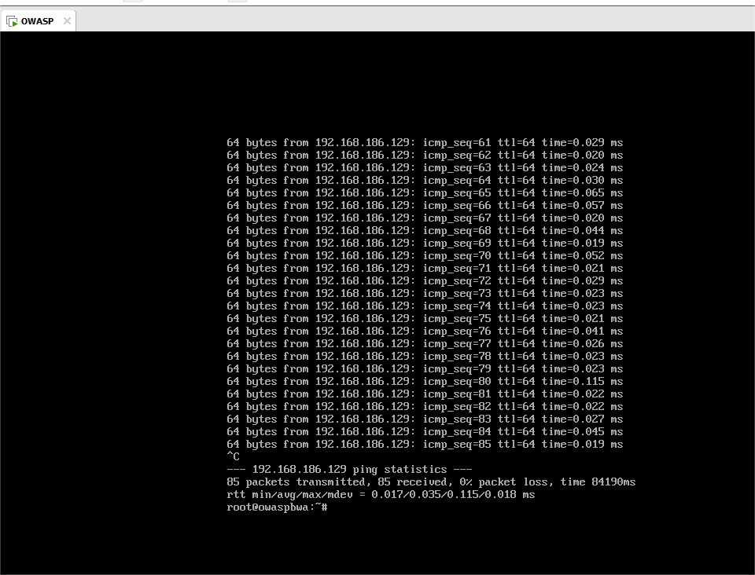

**Which OSI layer does the ping command operate in? Explain.**

It operates on the network layer. **ICMP (Internet Control Message Protocol)**:

* ICMP (Internet Control Message Protocol) is the core protocol used by the **ping** command. It operates at the **Network Layer** (Layer 3) because it is used to exchange control and error messages between network devices, such as routers and hosts, primarily for network-layer issues like IP addressing and routing. ICMP is used for diagnostic purposes (like ping and traceroute), to check if a destination device is reachable, or to test network performance.

# Exercise 3: Tracing the Path to the OWASP Application

**Question:**

**How many hops did it take to reach the OWASP VM?**

It took only one hop.

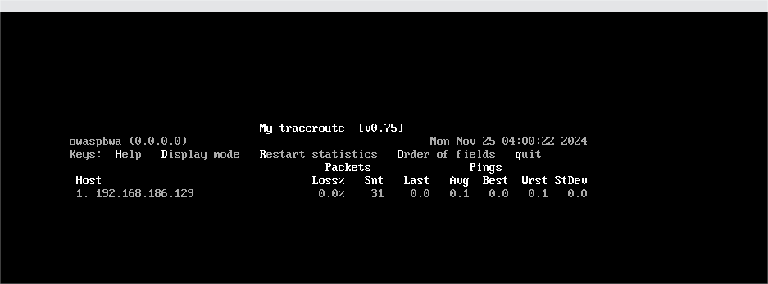

**Describe the significance of each hop and what role traceroute plays in network troubleshooting.**

It has a single hop because the traffic is routed directly through the virtualized environment or the host machine's virtual network interface.

# Exercise 4: Viewing Active Connections to OWASP VM

**Question:**

**What connections do you see? Identify the source and destination IP addresses.**

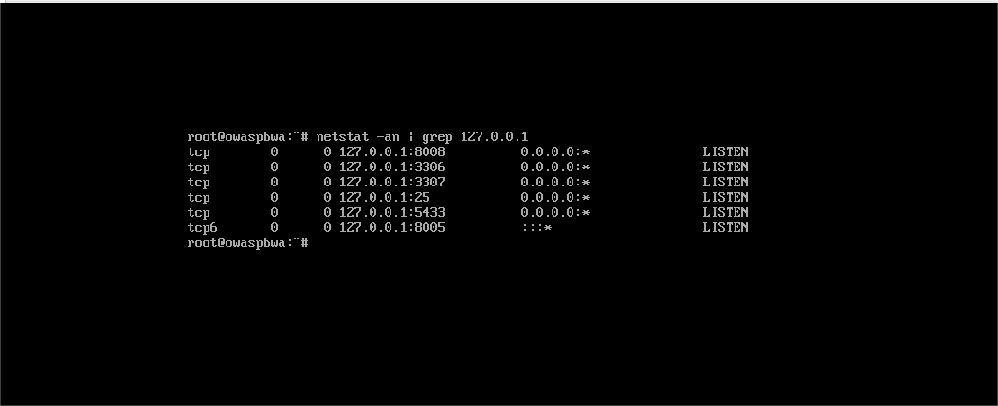

I tried using my IP address 192.168.186.129 but there was no connection i.e. no listening. So, I used the local address 127.0.0.1, this had a connection.

**Connection 1: LISTENING on 127.0.0.1:8008**

* **Source**: 127.0.0.1:8008 (Local IP and port where the application is listening)
* **Destination**: 0.0.0.0:* (The application is waiting for any incoming connections on port 8008)

The same explanation covers the other 5 connections.

**Explain how the Transport Layer (TCP/UDP) is involved in this communication.**

In the above example, the communication uses TCP (Transmission Control Protocol) as shown by the tcp in the output of netstat. Here’s how TCP is involved:

1. Three-Way Handshake: For an active connection, TCP uses a process called the three-way handshake to establish the connection:
   * + The client sends a SYN (synchronize) message to the server.
     + The server responds with a SYN-ACK (synchronize-acknowledgment) message.
     + The client then sends an ACK (acknowledgment) message back to the server, completing the handshake and establishing the connection.
2. **Reliable Data Transfer**: Once the connection is established, TCP ensures that data is reliably transferred between the two processes. This is important for web applications like the OWASP application because it guarantees that the data (e.g., HTTP requests and responses) will be transmitted correctly and in order, even if packets are lost in transit.
3. **Port Numbering**: The source and destination ports are used by TCP to keep track of which application on the local machine should handle the incoming/outgoing data.
4. **Stateful Communication**: Since TCP is a stateful protocol, it tracks the state of the communication between the two endpoints. This means that if either side fails to acknowledge a message, the connection can be retried until it is successfully completed.

# Exercise 5: TCP vs. UDP

**Question:**

**What are the key differences between TCP and UDP in terms of reliability and speed?**

* TCP is reliable but slower, making it suitable for applications where data integrity and correctness are essential.
* UDP is faster but less reliable, making it ideal for applications that need quick data transmission, where occasional data loss is acceptable.
* However, my UDP scan took longer because **UDP** scans require the scanner to wait for responses or timeouts from the target system.

**Based on the scan results, list which services on the OWASP application are using TCP and which are using UDP.**

I couldn’t use OWASP due to several errors I couldn’t solve before the deadline, so I used Kali.

**TCP Services:**

The following **TCP** ports are open and associated with specific services:

* **22/tcp**: SSH (Secure Shell)
* **80/tcp**: HTTP (Hypertext Transfer Protocol)
* **139/tcp**: NetBIOS (Network Basic Input/Output System)
* **143/tcp**: IMAP (Internet Message Access Protocol)
* **443/tcp**: HTTPS (Hypertext Transfer Protocol Secure)
* **445/tcp**: Microsoft-DS (Microsoft Directory Services)
* **5001/tcp**: Commplex Link (used for remote communications, typically proprietary)
* **8080/tcp**: HTTP-Proxy (used for web proxy services)
* **8081/tcp**: BlackIce-ICECAP (BlackICE software, often related to firewall or intrusion detection)

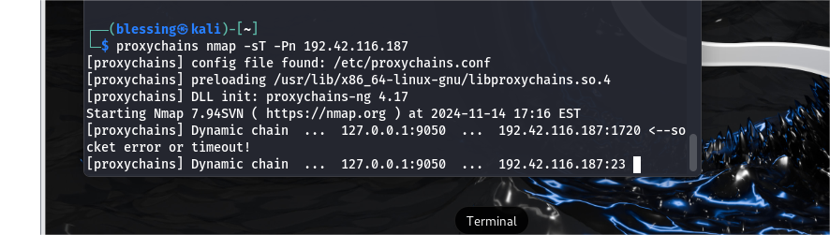

**UDP Services:**

The following **UDP** ports are open and associated with specific services:

* **137/udp**: NetBIOS-NS (NetBIOS Name Service)

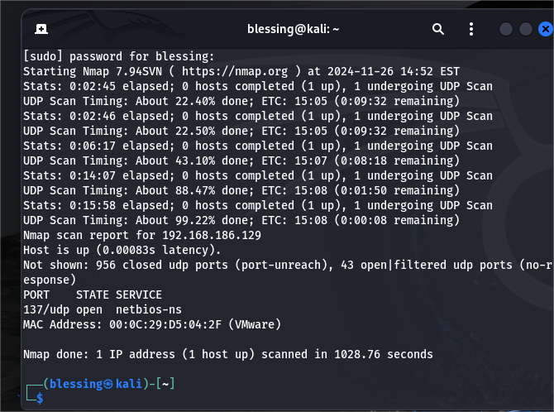

**Why UDP Scan Took So Long:**

The **UDP scan** took longer (1028.76 seconds) because **UDP** scans require the scanner to wait for responses or timeouts from the target system. Many UDP ports can be **filtered or closed**, causing the scanner to wait for responses or timeouts, and this can significantly increase scan time compared to a **TCP scan**, which has more predictable behavior due to its connection-oriented nature.

# Exercise 6: Discovering MAC Addresses with ARP

**Question:**

**What is the MAC address associated with the OWASP VM’s IP?**

The MAC address associated is **00:0c:29:d5:04:2f.**

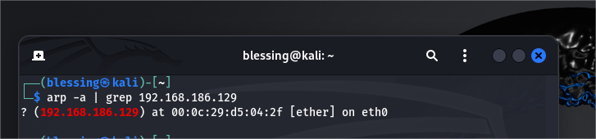

**Explain the significance of ARP in the Data Link Layer and how it contributes to successful Communication.**

ARP plays a vital role in network communication at the Data Link Layer by enabling devices to discover each other’s MAC addresses based on IP addresses. It facilitates local communication within a network and is an essential part of the networking stack. Without ARP, devices would not be able to identify the correct MAC addresses needed to send Ethernet frames, disrupting communication within local networks.

# Exercise 7: Capturing Network Traffic with Wireshark

**Question:**

**Analyze the captured traffic. What protocols are in use?**

**Can you identify the handshake process or other significant events in the captured packets?**

INT303: Networking Fundamentals – Lab 2

# Lab 2: Exploring Network Interfaces and Packet Transmission Using OWASP Broken Web Application IP

# Exercise 1: Viewing and Configuring Network Interfaces

**Question:**

**What network interfaces are available on your system?**

There are 2 network interfaces available: eth0 (ethernet interface) and lo (loopback interface).

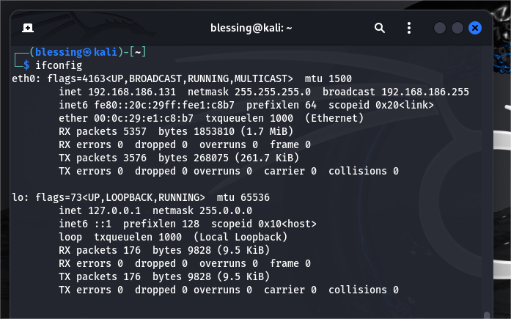

**Identify the IP address assigned to each interface.**

eth0: 192.168.186.131

lo: 127.0.0.1

**Describe the difference between a loopback interface and an external network interface**

The loopback interface is used for internal communication within the device itself, while an external network interface connects the device to the outside world (local network or internet). The loopback interface has no physical network connection, and traffic stays local, whereas the external network interface interacts with physical networking devices and enables communication with other devices or networks.

# Exercise 2: Capturing Packets on a Specific Interface

**Question:**

**What kind of packets are being captured?**

1. Multicast Listener Reports (ICMPv6 and IGMP v3).

2. ARP Requests.

3. MDNS Queries and Responses.

4. Repeated ARP Requests.

5. ICMP6 and ARP for Neighbor Discovery.

**Are there any packets related to communication with the OWASP Broken Web Application VM?**

Based on the provided packet capture data, there are no clear indications of direct communication with the OWASP Broken Web Application VM.

**Describe the role of this network interface in transmitting and receiving packets.**

The network interface serves as the vital communication link between a device and the network. It is responsible for the physical transmission and reception of data packets, and it performs important tasks such as encapsulation, addressing, error checking, and sometimes traffic management. Without a functioning network interface, a device cannot send or receive packets, making it essential for all networked communications.

# Exercise 3: Examining Network Statistics

**Question:**

**What is the current status of your network interfaces?**

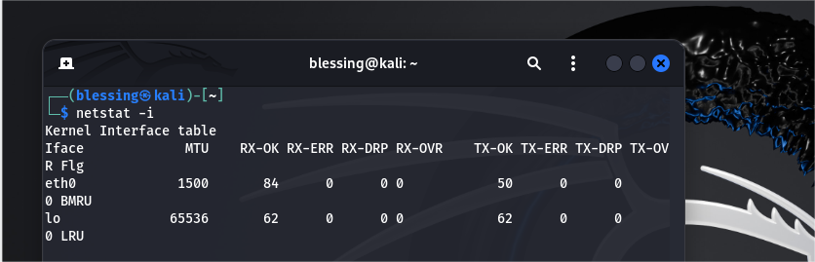

Interface: eth0

* MTU (Maximum Transmission Unit): 1500 bytes, which is typical for Ethernet interfaces.
* RX-OK (Received packets): 84 packets have been successfully received on this interface.
* RX-ERR (Receive errors): 0 errors during packet reception.
* RX-DRP (Received dropped packets): 0 packets have been dropped.
* RX-OVR (Receive overruns): 0 packets have been lost due to buffer overruns.
* TX-OK (Transmitted packets): 50 packets have been successfully transmitted.
* TX-ERR (Transmit errors): 0 errors during packet transmission.
* TX-DRP (Transmitted dropped packets): 0 packets have been dropped during transmission.
* TX-OVR (Transmit overruns): 0 packets lost due to buffer overruns.
* Flags: BMRU (Broadcast, Multicast, Running, Up) – Indicates the interface is up and running, and capable of broadcasting and multicasting.

Interface: lo (Loopback interface)

* MTU: 65536 bytes, a larger MTU suited for internal communication on the local machine.
* RX-OK: 62 packets have been successfully received.
* RX-ERR: 0 errors on reception.
* RX-DRP: 0 packets have been dropped.
* RX-OVR: 0 packets have been lost due to buffer overruns.
* TX-OK: 62 packets have been successfully transmitted.
* TX-ERR: 0 errors on transmission.
* TX-DRP: 0 packets have been dropped.
* TX-OVR: 0 packets lost during transmission.
* Flags: LRU (Loopback, Running, Up) – The loopback interface is up and running, used for communication within the local system.

Conclusion:

* Both interfaces, eth0 and lo, are operational with no errors, dropped packets, or buffer overflows.
* The eth0 interface is handling both incoming and outgoing packets successfully, though the number of transmitted packets is lower than received, which might indicate lower outbound traffic.
* The loopback interface (lo) is functioning normally, handling internal traffic between system processes.

This suggests a healthy network configuration with no significant issues.

**What active connections are visible?**

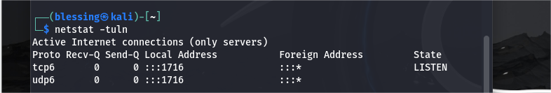

1. The system has a service listening on port 1716 for both TCP (IPv6) and UDP (IPv6).

2. The service is accessible from any remote machine using IPv6, as it is listening on all available interfaces (:::1716).

3. The state of the TCP service is LISTEN, which means it is ready to accept incoming connections.

4. The UDP service is simply waiting for incoming packets.

**Explain the significance of these statistics in monitoring network performance**

Monitoring network performance is essential for ensuring that a system's network interfaces are functioning optimally and to diagnose potential issues like bottlenecks, errors, or security threats. The statistics shown in the netstat -i output provide critical insight into the state of the network interfaces and active connections

**netstat -i (Network Interface Statistics):**

This command provides details about the status of each network interface (like eth0 or lo), showing the number of packets transmitted and received, as well as any errors or drops.

**netstat -tuln (Active Connections):**

This command lists active network connections and listening ports, providing insight into what services are running and accessible via the network.

# Exercise 4: Monitoring Network Traffic with Wireshark

**Question:**

**Analyze the packets going to and from the OWASP VM. What types of protocols are in use?**

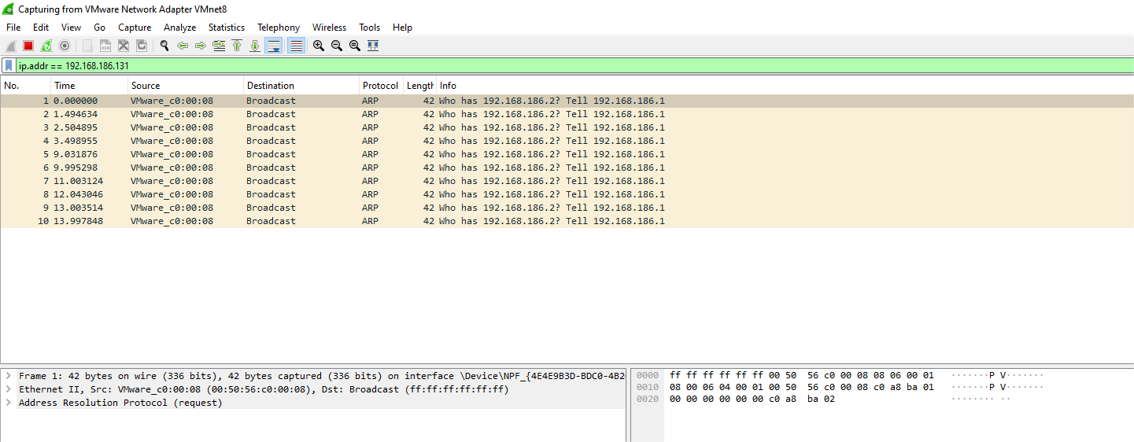

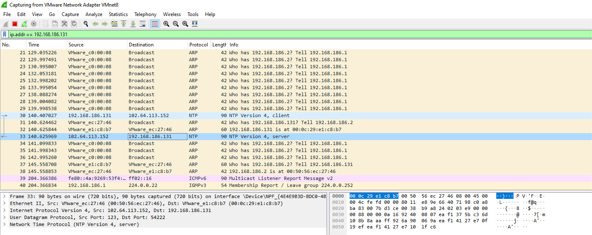

1. ARP (Address Resolution Protocol): Used for mapping the IP address 192.168.186.2 to a MAC address, necessary for local network communication.
2. NTP (Network Time Protocol): Used for synchronizing the time between the OWASP VM (192.168.186.131) and the NTP server (102.64.113.152), ensuring that the system clock of the VM is accurate and in sync with a standard time source.

These two protocols are involved in the network communication:

* ARP is used for local IP-to-MAC resolution on the network.
* NTP is used for time synchronization, ensuring that the OWASP VM's clock is accurate.

**Can you identify any key packet details such as source/destination IP addresses, port numbers, and flags?**

**140.407027 192.168.186.131 102.64.113.152 NTP 90 NTP Version 4, client33**

For the above packet:

Source IP: 192.168.186.131 (OWASP VM)

Destination IP: 102.64.113.152 (NTP server)

Source Port: Typically dynamically assigned (not visible in the output).

Destination Port: 123 (Standard NTP port)

Protocol: NTP (UDP-based, no TCP flags)

**140.625969 102.64.113.152 192.168.186.131 NTP 90 NTP Version 4, server**

For the above packet:

Source IP: 102.64.113.152 (NTP server)

Destination IP: 192.168.186.131 (OWASP VM)

Source Port: 123 (Standard NTP port)

Destination Port: Dynamically assigned high port (client-side)

Protocol: NTP (UDP-based, no TCP flags)

**How does the TCP/IP model apply to the data captured?**

1. Network Access Layer:

* ARP operates at this layer to facilitate local network communication by mapping IP addresses to MAC addresses.
* The MAC address in the ARP request is crucial for sending data on the local network.

1. Internet Layer:

* The Internet Protocol (IP) addresses used in the ARP and NTP packets (192.168.186.131, 192.168.186.130, 102.64.113.152, etc.) operate at this layer. This layer is responsible for routing the data from the source IP address to the destination IP address.

1. Transport Layer:

* The Transport Layer (Layer 3) for the NTP packets is UDP. UDP is a connectionless protocol used by NTP for fast communication without the need for handshakes or acknowledgments.
* Port 123 is used for both NTP client requests and NTP server responses.

1. Application Layer:

* At the Application Layer (Layer 4), NTP operates to synchronize the system clocks between the client and the server. It ensures that both devices have accurate and synchronized time for logging, scheduling, and various network operations.

# Exercise 5: Packet Transmission Analysis

**Question:**

**What do you observe during the packet transmission process?**

Observations from the Packet Capture:

**DHCP Activity:**

The DHCP server (192.168.186.254) is actively providing network configuration to the device 192.168.186.131, indicating that the device might be going through an initial connection or re-configuration phase.

**Multiple ARP Requests:**

There are repeated ARP requests from different devices trying to resolve the MAC address of 192.168.186.131. This suggests that there is a lack of a cached entry for 192.168.186.131, or that the ARP cache is being cleared often.

The ARP request with 192.168.186.131 as both the source and destination IP address indicates the device might be attempting to resolve its own MAC address.

**Network Traffic Volume:**

The constant ARP traffic could also point to network congestion or configuration issues. If devices are continuously sending ARP requests, it might be due to network instability or misconfiguration.

**Packet Length:**

The ARP packets have a length of 28 bytes, which is typical for an ARP request.

The DHCP reply packets have a length of 300 bytes, indicating that the DHCP reply includes necessary configuration information, such as IP address, lease time, subnet mask, and possibly gateway and DNS servers.

**Describe the handshake process or the round-trip of the packets for ping or TCP connection.**

* TCP Handshake (3-Way Handshake): This is used to establish a reliable communication session between a client and a server. It involves three key steps: SYN, SYN-ACK, and ACK, ensuring both sides are synchronized before data transfer begins.
* Ping Process: The ping process uses ICMP Echo Request and Echo Reply messages to test if a network destination is reachable. It is a simple, stateless method for network diagnostics but does not establish a full connection like TCP.

Each of these processes plays an essential role in networking, either for establishing full, reliable communication (TCP) or for testing basic connectivity (ping).

**Which layers of the OSI and TCP/IP models are involved in this transmission?**

* TCP Handshake involves Physical, Data Link, Network, Transport, and Application layers in both the OSI and TCP/IP models, but the primary operation occurs at the Transport layer, where TCP manages the connection.
* Ping Process is simpler, involving Physical, Data Link, Network, and Application layers, but does not use the Transport layer because ICMP is a connectionless protocol that directly operates at the Network Layer.

# Exercise 6: Troubleshooting Network Interface Issues

**Question:**

**What happens when you disable the network interface?**

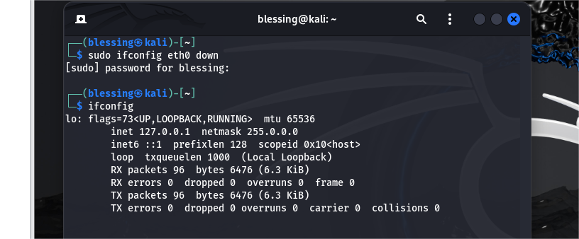

The eth0 is no longer listed as "up" and did not appear in the output at all.

**How does your system respond when the interface is re-enabled?**

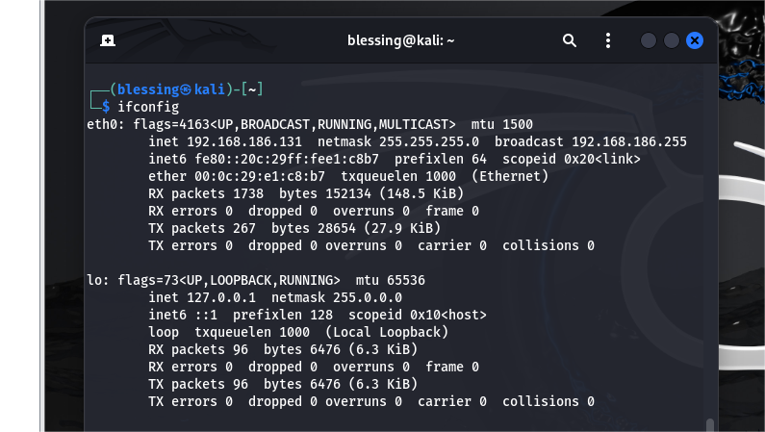

The interface became listed as ‘up’ again.

**Explain how network administrators can use this knowledge for troubleshooting connectivity issues.**

**It includes:**

* **Isolation of Problems:** Disabling the interface helps isolate the problem to either the network card, physical layer, configuration, or routing issues.
* **Service Testing:** Network admins can test services, applications, and network configurations by toggling the interface state.
* **IP and DHCP Troubleshooting:** It helps verify that the system is correctly obtaining an IP address or receiving the correct DHCP settings.
* **Routing & Failover Tests:** The process allows for testing failover configurations, routing, and firewall rules.
* **Network Performance:** Administrators can use this method to ensure that multiple interfaces or redundant connections work as expected.

That is, disabling and enabling network interfaces is a fundamental diagnostic tool in network troubleshooting. It allows administrators to narrow down the root cause of connectivity problems, test configurations, and verify that the system's network setup is functioning as expected.

# Exercise 7: Bandwidth Monitoring

**Question:**

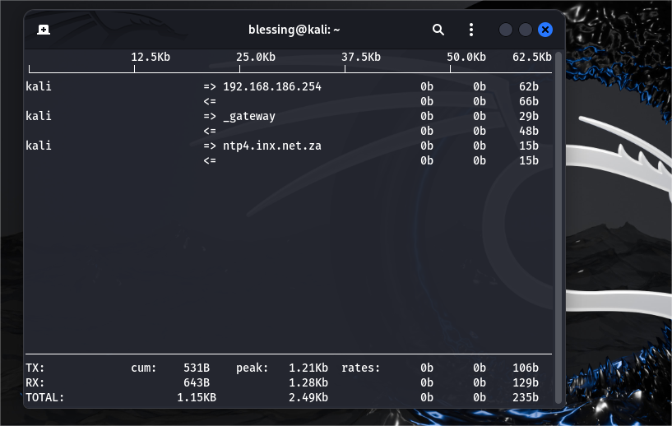

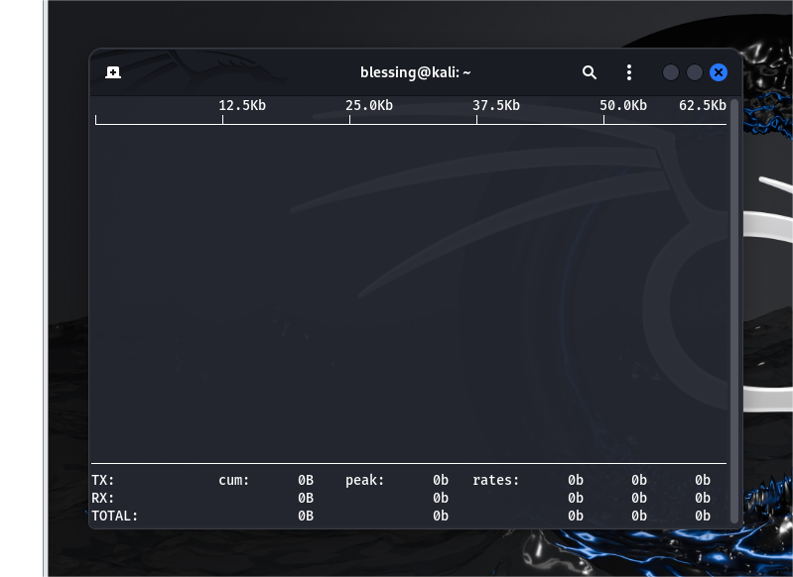

**What is the current bandwidth usage while communicating with the OWASP VM?**

The current bandwidth usage while communicating with the OWASP VM appears to be 0B (zero bytes) for both transmission (TX) and reception (RX).

While for my kali, it is 531B for (TX) transmission and 643B for (RX) reception.

**Identify the impact of network traffic on your interface. Is there any traffic congestion?**

There is no traffic congestion. The traffic is light.

**How does this help in monitoring network performance?**

Monitoring TX and RX data is critical for understanding network traffic flow and performance. By keeping track of the volume of transmitted and received data, error rates, and any signs of congestion, network administrators can:

* Identify network issues before they affect users.
* Optimize network performance by adjusting capacity or changing configurations.
* Ensure that traffic is balanced and network resources are efficiently allocated.

# Exercise 8: Advanced Packet Capture Filters

**Question:**

**What is the significance of filtering specific traffic?**

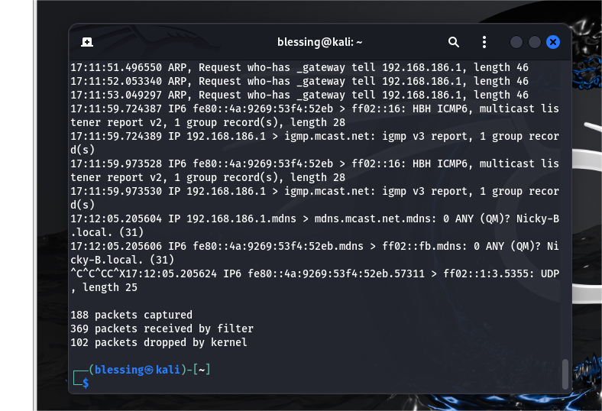

1. It focuses on relevant traffic which includes reduced data overload, and improved visibility.
2. It troubleshoots network issues which allows you to see only the packets related to HTTP (port 80). This makes it easier to identify issues.
3. **Monitoring Web Traffic:** filtering for **HTTP traffic on port 80** allows you to see the specific interactions between clients and the server.
4. **Identifying Malicious Traffic**: Filtering traffic based on certain protocols and IP addresses is also an effective way to spot **security threats**. E.g. If an attacker is targeting the web server at 192.168.186.131 with a **Denial-of-Service (DoS)** attack, you can identify this by monitoring unusually high amounts of **HTTP requests** coming to port 80.
5. **Bandwidth Consumption**: Filtering by port or host lets you analyze specific traffic to understand how much bandwidth is being consumed by certain services. E.g. If you filter for HTTP traffic on port 80, you can see how much data is being transmitted by web services.
6. **Instant Feedback**: The command used with tcpdump gives you **real-time data**, helping you monitor ongoing network activities and instantly catch issues like failed connections, delays, or high traffic. It’s especially helpful during **live troubleshooting** or monitoring.
7. **Efficiency**: Capturing all packets on a busy network interface can generate a lot of data and overwhelm both the capture tool and the system it's running on. By filtering traffic for only specific protocols or IP addresses, you reduce the amount of data that needs to be processed and stored.

**How can advanced filters help network engineers diagnose and resolve issues?**

Advanced filters in network tools like tcpdump and Wireshark significantly improve a network engineer's ability to diagnose, troubleshoot, and resolve issues by:

* Narrowing focus to relevant traffic.
* Isolating performance, security, or application-related problems.
* Detecting network errors, protocol issues, and misconfigurations quickly.
* Reducing resource usage while maintaining efficient, detailed monitoring. By mastering advanced filters, engineers can optimize their workflow and minimize the time it takes to identify and resolve network problems.

INT303: Networking Fundamentals – Lab 3

# Lab 3: TCP/IP Protocol Stack and Packet Inspection Using OWASP Broken Web Application IP

# Exercise 1: Understanding the TCP/IP Model

**Question:**

**Explain the differences between the TCP/IP and OSI models.**

|  |  |  |
| --- | --- | --- |
| **Feature** | **TCP/IP Model** | **OSI Model** |
| **Layers** | 4 layers (Application, Transport, Internet, Network Access) | 7 layers (Application, Presentation, Session, Transport, Network, Data Link, Physical) |
| **Purpose** | Practical implementation of internet protocols | Conceptual model for network communication |
| **Protocol Focus** | Focuses on specific protocols like TCP/IP | General guideline, no specific protocol focus |
| **Layer Definitions** | Fewer, broader layers (combined functions) | More detailed and specific layers |
| **Development** | Developed for ARPANET/Internet | Developed by ISO for general network standards |
| **Adoption** | Standard for modern internet communication | Primarily educational and theoretical |
| **Flexibility** | More flexible and practical | More rigid and theoretical |

**Which layers of the TCP/IP model correspond to specific OSI layers?**

* The TCP/IP Application Layer combines the Application, Presentation, and Session Layers from the OSI model because it handles a broader range of tasks related to application protocols and communication.
* The TCP/IP Transport Layer directly corresponds to the OSI Transport Layer, both handling end-to-end communication and error management.
* The TCP/IP Internet Layer corresponds to the OSI Network Layer, which focuses on logical addressing, routing, and packet delivery across networks.
* The TCP/IP Network Access Layer merges the responsibilities of the OSI Data Link and Physical Layers, dealing with physical network transmission and error control between devices.

# Exercise 2: Capturing and Analyzing TCP Packets

**Question:**

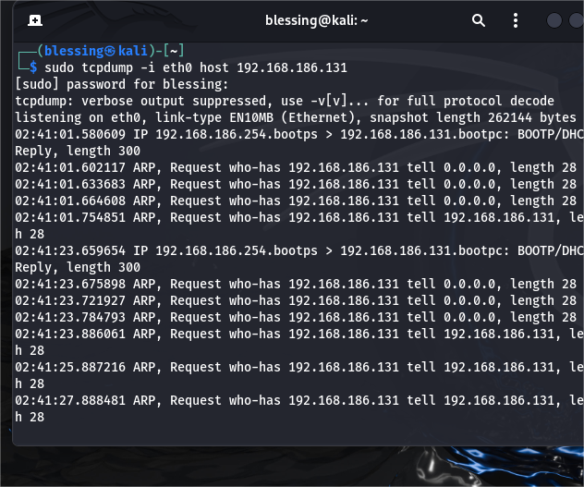

**What happens during the TCP handshake (SYN, SYN-ACK, ACK)?**

* The three-way handshake ensures both the client and server are ready and synchronized for data exchange.
* Sequence numbers are used to maintain order and ensure data integrity.
* This handshake also helps in handling network issues like packet loss or retransmissions during data transfer.

**Identify and describe the flags used in TCP communication (SYN, ACK, FIN, etc.).**

1. SYN (Synchronize)

* Purpose: Used to initiate a connection between two devices during the three-way handshake.
* Function: The SYN flag is set when a device wants to synchronize sequence numbers for the connection. It is typically the first step in establishing a TCP connection.
* Example: The client sends a SYN flag to the server to request the initiation of a connection (SYN → Server).

2. ACK (Acknowledgment)

* Purpose: Used to acknowledge the receipt of data.
* Function: The ACK flag is set when a device is confirming that it has successfully received a segment of data. The acknowledgment number in the packet corresponds to the sequence number of the next byte of data expected.
* Example: In the three-way handshake, both the client and the server exchange SYN-ACK and ACK flags to acknowledge receipt and readiness to proceed.

3. FIN (Finish)

* Purpose: Indicates that the sender has finished sending data and wishes to terminate the connection.
* Function: The FIN flag is set when one side of the connection wants to close the session. It tells the other side that no more data will be sent by the sender. However, the connection is not fully closed until the other side acknowledges the FIN flag.
* Example: When a device has finished transmitting data, it sends a FIN to the other device, signaling the beginning of the connection termination process.

4. RST (Reset)

* Purpose: Used to forcibly reset a connection.
* Function: The RST flag is set to abruptly terminate a connection, often in response to an error or invalid state. This flag tells the other device that something has gone wrong and that the connection should be reset.
* Example: If a device receives a TCP packet with an unexpected or incorrect sequence number, it may send a RST flag to reset the connection.

5. PSH (Push)

* Purpose: Used to push data to the receiving application immediately.
* Function: The PSH flag signals the receiver to deliver the data to the application layer immediately, rather than buffering it for later delivery. This is often used in interactive applications like telnet or web browsing, where real-time data is required.
* Example: When sending real-time data, such as keyboard input or web page requests, the PSH flag ensures that the data is promptly pushed to the receiving application without delay.

6. URG (Urgent)

* Purpose: Indicates that the data being sent is urgent and should be prioritized.
* Function: The URG flag is set when the sender wants to transmit urgent data that must be processed before other data. It works in conjunction with the Urgent Pointer field in the TCP header, which specifies the end of the urgent data.
* Example: In certain scenarios, such as network management or control signals, the URG flag is used to mark specific data as urgent, prompting the receiver to process it immediately.

7. ECE (ECN Echo)

* Purpose: Used for Explicit Congestion Notification (ECN) to indicate that congestion has been detected.
* Function: The ECE flag is part of ECN, a mechanism to signal network congestion without dropping packets. When this flag is set, it indicates that the receiver has detected congestion in the network.
* Example: In a connection that uses ECN, if congestion is detected, the ECE flag is set to inform the sender about the congestion.

8. CWR (Congestion Window Reduced)

* Purpose: Used in ECN to notify that the sender has reduced its congestion window size in response to congestion.
* Function: The CWR flag indicates that the sender has acknowledged the congestion notification (via ECE) and has reduced its sending window to avoid further congestion.
* Example: After receiving an ECE signal about congestion, the sender responds with CWR to indicate it has taken action to reduce traffic.

**How does the TCP connection maintain reliability during transmission?**

**1. Connection Establishment (Three-Way Handshake)**

* Before data transfer begins, TCP uses a **three-way handshake** (SYN, SYN-ACK, ACK) to establish a reliable connection between the sender and receiver. This handshake ensures both sides are ready for communication and agree on initial sequence numbers, which are essential for tracking the data's order during transmission.

**2. Sequencing**

* **Sequence Numbers**: TCP assigns a **sequence number** to each byte of data sent. These numbers are used to maintain the order of the data. Even if packets arrive out of order, the receiver can reassemble them correctly based on the sequence numbers.
* **Ensures Data Order**: Since TCP is a **connection-oriented protocol**, it ensures that data is received in the correct order by using these sequence numbers. If packets are out of order, the receiver can request retransmission of the missing or incorrectly ordered packets.

**3. Acknowledgments (ACKs)**

* After receiving data, the receiver sends back an **acknowledgment (ACK)** message to the sender, confirming the successful receipt of data. The acknowledgment contains the next expected sequence number, meaning that all data up to that point has been successfully received.
* **Cumulative Acknowledgment**: In TCP, ACKs are cumulative. This means that an ACK for a particular sequence number also implies that all previous packets have been successfully received.

**4. Retransmission (Loss Recovery)**

* **Timeout and Retransmission**: If the sender does not receive an acknowledgment for a segment within a specified time (the **timeout period**), it assumes the packet was lost or corrupted and **retransmits** it.
* **Duplicate ACKs**: If the receiver detects that a packet is missing (i.e., it receives an out-of-order packet), it sends a **duplicate ACK** for the last successfully received packet, prompting the sender to retransmit the missing packet. This mechanism is known as **Fast Retransmit**.

**5. Error Checking (Checksums)**

* TCP uses **checksums** to detect errors in the transmitted data. Each packet includes a checksum value that is calculated based on the data in the segment. The receiver recalculates the checksum and verifies that it matches the checksum sent with the packet. If there is a mismatch (indicating data corruption), the receiver discards the packet and the sender will retransmit it.

**6. Flow Control (Sliding Window)**

* **Sliding Window**: TCP uses a **sliding window** mechanism to control the amount of data sent before requiring an acknowledgment. The window size is dynamically adjusted based on the receiver's buffer space and network conditions. This ensures the receiver is not overwhelmed by too much data at once, preventing congestion and allowing for efficient data flow.
* **Receiver Window Size**: The receiver informs the sender of its available buffer space (the window size) in each ACK, enabling the sender to adjust the amount of data sent.

**7. Congestion Control**

* **Congestion Window**: To prevent network congestion, TCP employs **congestion control** algorithms that dynamically adjust the rate of data transmission based on network conditions. The sender uses a **congestion window** that grows and shrinks in response to perceived congestion.
* **Algorithms like Slow Start and Congestion Avoidance**: TCP uses several algorithms to manage congestion:
  + **Slow Start**: Initially, TCP sends data slowly, gradually increasing the transmission rate.
  + **Congestion Avoidance**: As packets are successfully acknowledged, the sender increases the window size to send more data.
  + **Fast Retransmit and Fast Recovery**: If packet loss is detected through duplicate ACKs, TCP reduces the transmission rate and recovers from the loss quickly.

**8. Connection Termination (Graceful Shutdown)**

* When the communication is complete, TCP ensures that both the sender and receiver agree to terminate the connection. This is done through a **four-way handshake** (FIN, ACK) to ensure that all data is transmitted and acknowledged before the connection is closed. This avoids the loss of data during termination.

# Exercise 3: Investigating IP Packets (Network Layer)

**Question:**

**What fields can you see in the IP packet header (e.g., Source IP, Destination IP, TTL, etc.)?**

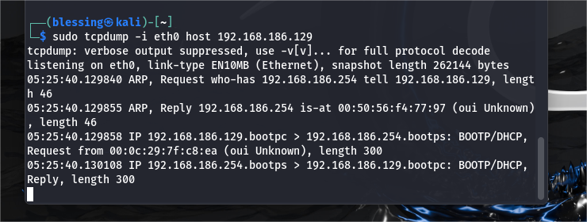

Key Fields in the IP Packet Header:

1. Source IP (OWASP 192.168.186.129 ):

This is the IP address of the device that is sending the packet.

1. Destination IP (192.168.186.254 or 192.168.186.255 in the diagram):

This is the IP address of the device to which the packet is being sent.

1. Time-to-Live (TTL):

The TTL field is a counter used to limit the lifetime of a packet. Each time the packet passes through a router, the TTL is decremented by 1. When it reaches zero, the packet is discarded. It helps prevent packets from circulating indefinitely in the network if there are routing loops.

1. Protocol:

This field specifies the higher-layer protocol used in the payload of the packet. In your capture:

* + - UDP (User Datagram Protocol) for netbios-dgm traffic.
    - BOOTP/DHCP for the DHCP-related packets.

This helps identify the type of data being transferred.

1. Length:

This is the total length of the IP packet, including both the header and the payload (data portion). For example, in the BOOTP/DHCP packets, you can see the packet length is 300 bytes.

1. IP Version:

The version of the IP protocol being used. Typically, this will be IPv4 (version 4) or IPv6 (version 6). Your example shows IPv4 packets.

1. Identification:

This is used to uniquely identify a fragmented packet. If a packet is too large to be transmitted in one piece, it can be fragmented, and each fragment will have the same identification field to indicate that they belong to the same original packet.

1. Flags and Fragment Offset:

These fields are used to indicate if a packet is fragmented and provide information on how to reassemble fragmented packets. This doesn't appear to be relevant in your current capture (as no fragments are mentioned).

1. Header Checksum:

This field is used for error-checking of the IP header. It ensures that the IP header has not been corrupted in transit.

Example from Diagram:

1. ARP Request and Reply:

ARP Request:

* + - ARP, Request who-has 192.168.186.254 tell 192.168.186.129, length 46
    - This packet is a request asking who has the IP address 192.168.186.254.

ARP Reply:

* + - ARP, Reply 192.168.186.254 is-at 00:50:56:f4:77:97 (oui Unknown), length 46
    - This packet provides the hardware (MAC) address of the device with IP 192.168.186.254.

1. BOOTP/DHCP Packets:

Request:

* + - IP 192.168.186.129.bootpc > 192.168.186.254.bootps: BOOTP/DHCP, Request from 00:0c:29:7f:c8:ea (oui Unknown), length 300
    - The source IP is 192.168.186.129, and the destination is 192.168.186.254. This is a DHCP request from the MAC address 00:0c:29:7f:c8:ea.

Reply:

* + - IP 192.168.186.254.bootps > 192.168.186.129.bootpc: BOOTP/DHCP, Reply, length 300
    - The source IP is 192.168.186.254, and the destination is 192.168.186.129. This is a DHCP reply.

1. NetBIOS Broadcasts:

IP 192.168.186.129.netbios-dgm > 192.168.186.255.netbios-dgm: UDP, length 232

This shows a NetBIOS packet being sent from 192.168.186.129 to the broadcast address 192.168.186.255. The protocol used is UDP, and the length is 232 bytes.

**What is the significance of each of these fields?**

1. Source IP Address:

* Significance: The source IP address specifies the origin of the packet, i.e., the device (host) that sent the packet. This allows the destination device to know where the packet came from, which is important for routing replies and for diagnosing network issues.
* Example: In the capture, the source IP 192.168.186.129 identifies the device sending the packet.

2. Destination IP Address:

* Significance: This field indicates where the packet is supposed to be delivered. The packet will be routed towards the destination IP across various routers and networks until it reaches the destination device.
* Example: In the capture, the destination IP 192.168.186.254 is where the packet is intended to go.

3. Time-to-Live (TTL):

* Significance: TTL helps to prevent packets from circulating indefinitely due to routing errors (like loops). Every time a packet passes through a router, its TTL is decreased by 1. If the TTL reaches 0, the packet is discarded. This ensures that packets don't flood the network.
* Example: A TTL value of 64 means that the packet can travel through up to 64 routers before being discarded.

4. Protocol:

* Significance: This field specifies which higher-layer protocol is encapsulated in the packet’s payload. It indicates whether the packet contains TCP, UDP, ICMP, or other protocol data. This helps the receiving system understand how to process the data.
* Example: UDP in the capture indicates that the packet carries User Datagram Protocol data, while BOOTP/DHCP indicates a DHCP request or response.

5. Length:

* Significance: The length field indicates the total size of the IP packet, including both the header and the data portion (payload). This is necessary for correctly parsing and processing the packet. The receiver can use this value to understand where the packet ends.
* Example: In the capture, the packet size is given as 300 bytes, indicating the total length of the packet.

6. Version:

* Significance: This field specifies the version of the IP protocol being used. Common versions include IPv4 and IPv6. This field allows the receiver to know how to interpret the packet since different versions have different header structures.
* Example: the capture shows IPv4 packets, as indicated by the IP version field.

7. Identification:

* Significance: This is used to uniquely identify fragments of a larger packet. If an IP packet is too large to fit in a single frame and must be fragmented, all fragments of the same original packet will have the same Identification value. This helps reassemble the fragmented packets back into the original data.
* Example: This field is particularly useful in situations where a large packet needs to be split into multiple fragments and reassembled by the receiving host.

8. Flags and Fragment Offset:

* Significance: These fields are used in packet fragmentation. The flags field indicates whether a packet is fragmented, and the fragment offset indicates the position of a fragment within the original packet. These fields help routers and receiving devices correctly handle fragmented packets.
* Example: The "Don't Fragment" flag tells routers not to fragment the packet, while the Fragment Offset specifies the fragment's position in the original data stream.

9. Header Checksum:

* Significance: The checksum is a form of error-checking to ensure the integrity of the IP header. It is calculated by the sender and verified by the receiver. If the checksum does not match the calculated value on the receiver's side, the packet is discarded as corrupted.
* Example: If the header is altered in transit (due to hardware failure, network issues, etc.), the checksum allows the receiver to detect this corruption.

10. Padding:

* Significance: Padding is used to ensure the IP header is a multiple of 32 bits (4 bytes). This ensures that the start of the payload (data portion) aligns correctly in memory. Padding is added if necessary to achieve this alignment.
* Example: Padding is typically not seen in most packet captures as it is usually transparent to the user and network.

11. IP Header Length (IHL):

* Significance: The IHL field specifies the length of the IP header in 32-bit words. It tells the receiver where the header ends and where the data (payload) begins. This is particularly important if the header includes options, as the header size may vary.
* Example: The typical IP header without options has an IHL value of 5 (indicating 5 * 32-bit words = 20 bytes).

**How does IP routing work in this scenario? Are there any hops between your system and the OWASP VM?**

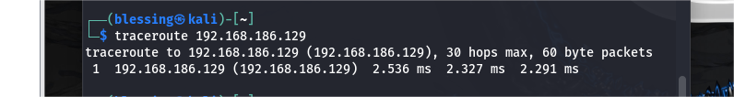

This output shows that there is only one hop, and the destination is 192.168.186.129 itself. Here's what this means in terms of IP routing:

IP Routing in This Scenario

1. Local Subnet Communication:  
   The traceroute output indicates that the system is directly communicating with the IP address 192.168.186.129 without any intermediate devices (routers) involved. The fact that you see 192.168.186.129 as the destination in the first hop (and the only hop) suggests that both the system and the OWASP VM are in the same local network or subnet.
2. No Routers (No Hops):  
   Since the traceroute response comes back from the destination in the first hop, it means that the packet doesn't need to go through any routers. Both devices (your system and the OWASPVM) are directly connected on the same local network, so there's no need for routing across different subnets.

Explanation of the Routing Process

In the case where the system and the OWASP VM are on the same network:

* Source System (the Machine): the system will first check its routing table. Since the destination IP (192.168.186.129) is in the same subnet as the machine, the packet is sent directly to the OWASP VM without involving any routers.
* Destination System (OWASP VM): The packet is directly received by the device with IP 192.168.186.129. The packet does not pass through any external routers, so the destination can immediately reply.

Why There Are No Hops

The absence of hops means that:

* Both devices are within the same subnet (likely determined by the subnet mask).
* No routing is required because the devices are able to communicate directly at the data link layer (Layer 2) through Ethernet or Wi-Fi, depending on your network setup.
* ARP (Address Resolution Protocol) will likely be used to resolve MAC addresses for communication at the Ethernet layer.

# Exercise 4: Application Layer Analysis (HTTP/SSH Traffic)

**Question:**

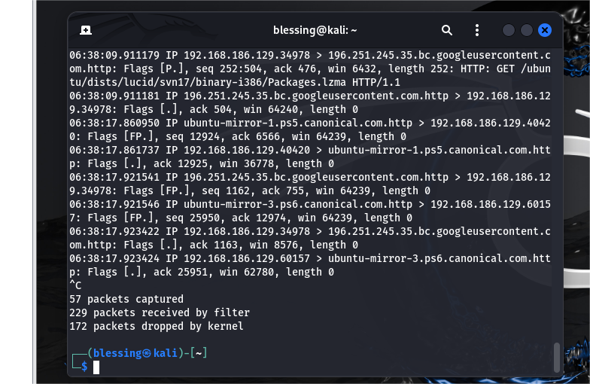

**Analyze the HTTP packets. What information is available in the HTTP request and response?**

**HTTP Response Packet (Packet # 6)**

Explanation:

* Source IP: ubuntu-mirror-1.ps5.canonical.com (Canonical mirror server).
* Destination IP: 192.168.186.129 (Your machine).
* Source Port: 80 (HTTP).
* Destination Port: 40420 (Client-side port).
* Flags: P (Push), indicating data is being sent as part of a session.
* Sequence Number: seq 1:499 — The response starts at byte 1 and has a length of 498 bytes.
* Acknowledgment Number: ack 188 — Acknowledging the receipt of data from the client (your system).
* Window Size: win 64240 — The receiver's buffer size.

HTTP Response:

* Status Code: HTTP/1.1 404 Not Found — The server is responding with a 404 error, indicating the requested resource (Release.gpg) was not found on the server.
* Content Length: This isn't explicitly shown here, but the length of the packet (498 bytes) suggests that it may contain additional information in the response body, such as the standard 404 error page content.

This shows that the resource requested (Release.gpg) is not available at the requested location on the server.

**Subsequent HTTP Request and Response (Packet # 8 and # 10)**

Here, the client retries by making a different HTTP GET request for a new resource after receiving the 404 response for the Release.gpg file.

The sequence follows:

1. GET /ubuntu/dists/lucid-security/Release — A request for the Release file.
2. GET /ubuntu/dists/lucid-security/main/binary-i386/Packages.bz2 — A request for a different resource after the initial 404 error.

**Key Information Available in HTTP Request and Response:**

1. Request Method:

The HTTP request method used is GET, which indicates the client is trying to fetch resources (files) from the server.

1. Requested URI:

The requested URIs include paths to Ubuntu release and package files, such as:

* + - /ubuntu/dists/lucid-security/Release.gpg
    - /ubuntu/dists/lucid-security/Release
    - /ubuntu/dists/lucid-security/main/binary-i386/Packages.bz2

1. HTTP Response Status:

The server responds with status codes like 404 Not Found, indicating that the requested resources are not available at the given URLs.

1. Content Length (Implied by Packet Lengths):
   * Although the actual content length of the HTTP responses is not explicitly shown, it is implied by the length of the TCP segments (e.g., 498 bytes for the 404 error response).
2. Connection Information:

The packet also reveals TCP details such as the sequence and acknowledgment numbers, window size, and the flags (e.g., Push and Acknowledgment flags) that control the flow of data between the client and the server.

1. HTTP Version:

All the requests and responses are using HTTP/1.1, which is the most commonly used HTTP version for web traffic.

1. Data Transfer:

The interaction involves several back-and-forth data exchanges, with the client making multiple requests after receiving 404 Not Found responses, showing a typical client-server communication where the client adjusts its requests based on the server's responses.

**For SSH traffic, what is the significance of encrypted packets? Can you analyze the payload?**

Significance of Encrypted Packets in SSH Traffic

1. Confidentiality:

SSH uses encryption to ensure that the data transmitted between the client and server remains private and confidential. The encryption ensures that even if a malicious actor intercepts the packets, they cannot read the contents of the communication.

SSH uses symmetric encryption (such as AES or ChaCha20) to encrypt the actual data once the session is established. This means that both the client and server share a secret session key that is used for encryption and decryption of the transmitted data.

The encryption ensures that commands sent via SSH, the results of those commands, and any other data transferred between the client and server remain secure.

1. Integrity and Authentication:

SSH provides mechanisms to ensure that the data has not been altered during transmission. This is achieved through the use of Message Authentication Codes (MACs). MACs are cryptographic checksums that are included in the encrypted packets, allowing both the client and server to verify the integrity of the data.

SSH also uses public key cryptography during the initial handshake to authenticate both the client and the server. This ensures that the communication is taking place between trusted parties.

1. Protection Against Eavesdropping and Replay Attacks:

Since the data is encrypted, it prevents eavesdroppers from understanding the content even if they intercept the packets.

SSH also uses sequence numbers to protect against replay attacks, ensuring that an attacker cannot simply replay captured packets to gain unauthorized access.

When SSH traffic is captured using packet-sniffing tools like tcpdump or Wireshark, you only see the encrypted data. This means the actual contents of the communication (such as commands issued, files transferred, or session data) are hidden and cannot be directly analyzed unless decrypted.

**How does the application layer play a role in data exchange between your system and the OWASP VM?**

The application layer plays a key role in the data exchange between your system (client) and the OWASP VM (server), particularly when interacting over protocols like SSH. It is responsible for defining the specific application protocols and the logic that governs communication, handling how data is presented, transmitted, and interpreted by both the sender (your system) and the receiver (OWASP VM).

# Exercise 5: Error Handling in TCP/IP Transmission

**Question:**

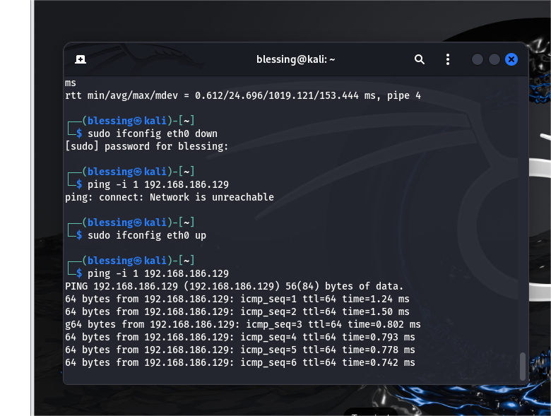

**What happens when packets are dropped or delayed?**

Packet Loss: When packets are lost due to network interface failure, TCP will detect the loss and attempt to retransmit the lost packets once the connection is re-established.

Network Delay: TCP/IP can handle network delays and will typically continue to retransmit data when necessary. The retransmission process ensures reliable data transfer, even during network disruptions.

**How does TCP ensure data reliability in the presence of errors?**

TCP ensures data reliability in the presence of errors through several mechanisms:

* Error detection using checksums.
* Reliable data delivery with sequence numbers and acknowledgments.
* Retransmissions of lost or corrupted packets.
* Flow control to prevent overwhelming the receiver.
* Congestion control to avoid overloading the network.
* Graceful connection establishment and termination to ensure proper communication.

**How do retransmissions and sequence numbers work in TCP to maintain a proper data flow?**

Sequence numbers help track and order data, ensuring the receiver can correctly reassemble it and acknowledge received data.

Retransmissions ensure reliability, with mechanisms such as timeouts and fast retransmit to recover from packet loss.

Together, sequence numbers and retransmissions ensure that data is reliably delivered in the correct order and that any lost or corrupted data is retransmitted until successfully received by the recipient.

# Exercise 6: ICMP and Ping Inspection (Network Layer)

**Question:**

**What are the key fields in an ICMP packet (e.g., Type, Code, Checksum)?**

An ICMP (Internet Control Message Protocol) packet consists of several key fields:

1. Type

* Description: Specifies the type of the ICMP message. It determines the purpose of the message and is essential for distinguishing between different types of ICMP messages (e.g., Echo Request, Echo Reply, Destination Unreachable).
* Example:

8 for Echo Request (ping)

0 for Echo Reply (response to ping)

3 for Destination Unreachable

2. Code

* Description: Provides further classification of the ICMP message type. Depending on the Type, the Code gives more specific information (e.g., why a destination is unreachable, or the source of an error).
* Example:

For Type 3 (Destination Unreachable), the Code might indicate:

* + - 0 (Network Unreachable)
    - 1 (Host Unreachable)
    - 2 (Protocol Unreachable)

3. Checksum

* Description: A 16-bit value used for error-checking of the ICMP packet. It ensures the integrity of the message by checking for any changes or corruption in the transmitted data. The checksum is calculated by taking the 16-bit one's complement of the one's complement sum of the 16-bit words in the header and data fields.
* Note: This field is mandatory for ensuring data integrity across network communication.

4. Identifier

* Description: Primarily used in Echo Request and Echo Reply messages. It helps match requests with replies by providing an identifier that is usually set to a unique value by the sender.
* Example: Used in the ping command to associate requests and replies.

5. Sequence Number

* Description: Also used in Echo Request and Echo Reply messages to track the sequence of messages. It is incremented with each request sent by the sender, allowing the receiver to match the correct reply to the corresponding request.
* Example: Typically a number that increases with each successive ping request.

6. Data

* Description: This field may vary depending on the type of ICMP message. In Echo Request and Echo Reply, this field usually contains arbitrary data (for example, a timestamp or other test data), which is echoed back in the reply message. In other types, it may carry more detailed information related to the error or network status being reported.

**How does ICMP assist in diagnosing network connectivity issues?**

ICMP assists in diagnosing network issues through:

* Ping (Echo Request/Reply): Verifies host availability and measures network latency.
* Traceroute (Time Exceeded): Traces the path packets take and identifies where delays or failures occur.
* Destination Unreachable (Type 3): Indicates network or host availability issues.
* Time Exceeded (Type 11): Identifies routing loops or excessive delays.
* Parameter Problem (Type 12): Highlights malformed packets or IP header issues.

**What is the significance of TTL in both ICMP packets and general IP packets?**

* TTL in General IP Packets: Prevents packets from circulating forever by limiting their number of hops in the network, thereby preventing congestion and resource depletion.
* TTL in ICMP Packets: Used for diagnostic purposes, especially in tools like ping and traceroute, to determine the number of hops to the destination and help identify network issues, delays, or routing loops.

# Exercise 7: Analyzing UDP Packets (Transport Layer)

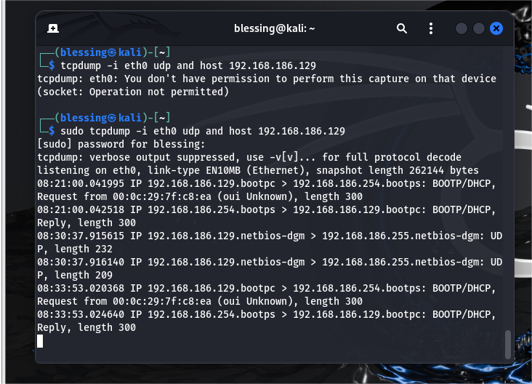

**Question:**

**Compare UDP with TCP. What are the major differences in packet structure and behavior?**

|  |  |  |
| --- | --- | --- |
| **FEATURE** | **TCP** | **UDP** |
| **Connection** | **Connection-oriented** | **Connectionless** |
| **Reliability** | **Reliable (retransmission, sequencing)** | **Unreliable (no retransmission)** |
| **Error Checking** | **Yes, with automatic retransmission** | **Yes, but no retransmission** |
| **Flow Control** | **Yes (flow and congestion control)** | **No** |
| **Packet Structure** | **Complex, with sequence numbers, flags, etc.** | **Simple, with source/destination port, length, and checksum** |
| **Transmission Order** | **Guarantees ordered delivery** | **No guarantee on order** |
| **Overhead** | **High (due to connection management)** | **Low (minimal header)** |
| **Use Cases** | **Reliable communication (web, file transfer)** | **Real-time communication (streaming, DNS, gaming)** |

**Why does UDP not ensure reliability, and in what scenarios would you prefer UDP over TCP?**

**Why Does UDP Not Ensure Reliability?**

UDP (User Datagram Protocol) is classified as a connectionless and unreliable protocol, primarily because it is designed for simplicity and low overhead. Unlike TCP (Transmission Control Protocol), which provides robust mechanisms to ensure data delivery and integrity, UDP does not offer these reliability features. Here are the key reasons why UDP does not ensure reliability:

1. **No Connection Setup:** UDP does not establish a connection between the sender and receiver before data transmission. There’s no handshake process (like TCP’s three-way handshake) to ensure that both sides are ready to communicate.
2. **No Acknowledgments:** UDP does not include any mechanism for confirming whether packets have been successfully received. In TCP, every transmitted packet is acknowledged by the receiver, and if a packet is not acknowledged (due to packet loss), it is retransmitted. UDP simply sends packets, and it is up to the application layer to handle retransmissions if needed.
3. **No Retransmission Mechanism:** If a UDP packet is lost during transmission (e.g., due to network congestion or errors), it will not be retransmitted. This lack of retransmission is a key reason why UDP is considered unreliable.
4. **No Flow Control:** UDP does not have mechanisms to manage the rate of data transmission between the sender and receiver. In contrast, TCP implements flow control to prevent the receiver from being overwhelmed by too much data at once.
5. **No Error Recovery:** While UDP does use a checksum to detect errors in the transmitted data, it does not attempt to correct errors. If data is corrupted during transmission, UDP simply discards the packet. In TCP, the protocol guarantees that data is delivered correctly by handling error recovery through retransmissions.
6. **No Ordered Delivery:** UDP does not guarantee that packets will be received in the order they were sent. This can lead to out-of-order delivery, especially when packets travel through different network paths or experience delays. TCP ensures data is delivered in the correct sequence through sequence numbers and reordering.

**In What Scenarios Would You Prefer UDP Over TCP?**

While UDP lacks reliability and guarantees, it has advantages in certain scenarios where speed, low overhead, and reduced latency are more important than ensuring data integrity. Here are some situations where UDP is preferred:

1. **Real-Time Communication (e.g., VoIP, Video Streaming):** In real-time applications, such as voice or video communication (e.g., VoIP, online gaming, video conferencing), low latency and fast transmission are critical. Small delays caused by retransmissions or waiting for acknowledgments (as with TCP) would disrupt the experience.

If a packet is lost, it’s often better to continue streaming the next packets rather than delay the entire stream for retransmission. Some loss is acceptable in these applications, but delays are not.

1. **DNS (Domain Name System) Queries:** DNS uses UDP because it's fast and efficient. DNS queries and responses are typically small and do not require the overhead of establishing a connection or waiting for acknowledgments. If a DNS query is lost, it’s typically just retransmitted quickly.
2. **TFTP (Trivial File Transfer Protocol):** TFTP is a simplified version of FTP used primarily for transferring configuration files or boot images over a network. It uses UDP because it is intended to be lightweight and does not require complex mechanisms like retransmission or connection management. If a packet is lost, it can be retransmitted by the application itself.
3. **Broadcast and Multicast Communication:** UDP supports broadcasting and multicasting, which are useful for sending data to multiple devices on a network simultaneously. For example, in network discovery protocols or streaming applications where the same data is sent to multiple receivers, UDP is often preferred due to its efficiency.

Since UDP does not establish a connection or require a handshake, it is well-suited for sending data to many devices at once without the overhead of TCP’s connection setup and tear-down processes.

1. **Online Gaming:** Many online multiplayer games use UDP because it allows for faster data transfer between players. Games often require rapid updates (e.g., player movements, actions) and can tolerate some packet loss, as long as the game remains responsive.

UDP minimizes the lag and overhead that would occur if the game had to wait for retransmissions (as would happen with TCP).

1. **Streaming Media (Audio and Video):** Live streaming applications (e.g., YouTube Live, live sports broadcasts) prefer UDP for video and audio streaming. These applications prioritize continuous media flow, where slight data loss is less important than minimizing delays or buffering.

Real-time video or audio typically doesn't suffer much from minor packet loss, as the viewer may not notice a brief disruption, but delays due to retransmissions or flow control could significantly impact the experience.

1. **Simple Request-Response Protocols:** Protocols that are simple and do not require guaranteed delivery or acknowledgment might also use UDP. For example, network time protocol (NTP) servers might use UDP because their queries and responses are brief, and the application can handle any necessary retries at a higher layer if the packet is lost.

**How does UDP manage data transmission without the need for acknowledgments or retransmissions?**

UDP (User Datagram Protocol) manages data transmission without the need for acknowledgments or retransmissions by operating as a connectionless and unreliable protocol. This design allows it to send data with minimal overhead and maximum speed but at the cost of reliability.

# Exercise 8: OS Detection via Nmap (Network and Transport Layers)

**Question:**

**How does nmap detect the OS based on the captured packets?**

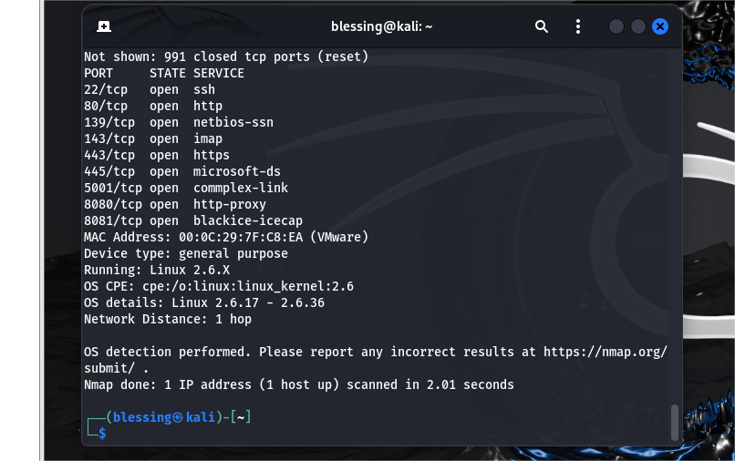

**Nmap OS Detection Process:**

1. Nmap sends a variety of probes to the target host using TCP, UDP, and ICMP packets.
2. The target host responds with network behavior that is influenced by the specific OS’s implementation of the network stack.
3. Nmap analyzes the responses by looking for subtle differences in the headers and other packet details (such as TTL, initial window size, flags, and sequence numbers).
4. Nmap compares this information with a database of known OS signatures to find a match.
5. Nmap provides an OS estimate based on the closest match from its database.

Thus, by analyzing how the target responds to various probes and comparing the responses with its database of OS fingerprints, Nmap can make a reasonably accurate determination of the target’s operating system.

In the diagram, for example, Nmap identified the target as running Linux 2.6.17 - 2.6.36, based on these characteristics.

**What packet characteristics (TTL, window size, etc.) help in identifying the OS?**

Packet Characteristics:

* TTL (Time-to-Live): Default values can indicate the OS (e.g., 128 for Windows, 64 for Linux).
* TCP Window Size: Different initial values help differentiate OSes (e.g., Windows tends to use larger values).
* IP Options: The presence of options like timestamping can indicate a Linux or other OS.
* Initial Sequence Number (ISN): Predictable ISNs can point to Windows, while randomized ISNs suggest Linux or Unix.
* TCP Flags: Differences in flag response behavior help distinguish OS types.
* Maximum Segment Size (MSS): Varies between OSes and can be used for identification.
* ICMP Responses: TTL values and the manner of replies can reveal OS details.
* Fragmentation Behavior: The way fragmentation is handled may indicate the OS.

These characteristics, when analyzed together, allow Nmap to perform effective **OS fingerprinting**, helping to detect the operating system running on a target machine.

**Explain why OS detection can be an important step in network analysis and vulnerability assessment.**

OS detection is a vital step in network analysis and vulnerability assessment because it provides a detailed understanding of potential risks, enables targeted security measures, optimizes incident response, and enhances overall network security. By knowing the specific OS, organizations can implement more effective defenses, improve patch management, and ensure that systems are compliant with relevant security standards. Furthermore, OS detection helps identify the attack surface, allowing security teams to anticipate and defend against OS-specific attacks.

# Exercise 9: Analyzing ARP Traffic (Link Layer)

**Question:**

**What information can you gather from ARP packets (e.g., MAC addresses)?**

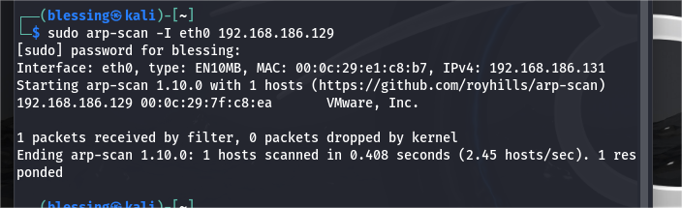

**The information includes:**

1. MAC Address:

* MAC: 00:0c:29:e1:c8:b7 for your interface (eth0).
* MAC: 00:0c:29:7f:c8:ea for the host (192.168.186.129).

The MAC address is used for communication within a local network (Layer 2 of the OSI model). It helps to uniquely identify devices on the network.

2. IPv4 Address:

* The system has an IP address of 192.168.186.131 and the MAC address 00:0c:29:e1:c8:b7.
* A device at IP 192.168.186.129 has the MAC address 00:0c:29:7f:c8:ea.

3. Vendor Information:  
The MAC address is associated with a specific hardware vendor. In the output, the device with MAC address 00:0c:29:7f:c8:ea is identified as a VMware device, which suggests that it is likely a virtual machine running on VMware virtualization software.

4. Response Information:  
The scan shows that only one device (192.168.186.129) responded to the ARP request, indicating that the network is reachable and at least one other device is active on the same subnet.

**How does the ARP protocol function at the link layer?**

**Here's how ARP protocol functions at the link layer:**

**1. ARP Request:**

* When a device needs to send data to another device on the same local network (i.e., within the same subnet), it needs the MAC address of the destination device.
* If the source device knows the destination device's IP address but not its MAC address, it sends out an ARP request. This is a broadcast message sent to all devices on the local network. The request is sent to the broadcast MAC address FF:FF:FF:FF:FF:FF.

**ARP Request Structure:**

* Sender IP: The IP address of the requesting device.
* Sender MAC: The MAC address of the requesting device.
* Target IP: The IP address of the destination device (whose MAC address is being requested).
* Target MAC: Set to 0, as it is the unknown address.

**2. ARP Reply:**

* The device with the matching IP address (in this case, the device with IP 192.168.1.20) will respond with an ARP reply. This is a unicast message sent directly to the requesting device, containing the MAC address of the target device.

**ARP Reply Structure:**

* Sender IP: The IP address of the device responding.
* Sender MAC: The MAC address of the device responding.
* Target IP: The IP address of the original requesting device.
* Target MAC: The MAC address of the target device (the one whose address was being requested).

**3. Caching:**

* After receiving the ARP reply, the requesting device (Device A) now has the MAC address of Device B and stores this information in its ARP cache.
* The ARP cache is a local table that maintains IP-to-MAC address mappings to avoid sending repeated ARP requests for the same destination. Entries in the ARP cache typically expire after a certain period if not used.

**4. Communication:**

* With the MAC address now known, Device A can send Ethernet frames to Device B. These frames will contain Device B's MAC address as the destination address, allowing them to communicate on the link layer.

**Key Points of ARP at the Link Layer:**

* Layer 2 to Layer 3 Translation: ARP resolves the mapping between Layer 3 IP addresses and Layer 2 MAC addresses, which is essential for local network communication.
* Broadcast & Unicast: ARP requests are broadcast to all devices in the local network, while ARP replies are unicast directly to the requesting device.
* Local Network Communication: ARP is used only within a local network or subnet. When devices are on different subnets, routers handle the IP-to-MAC resolution.

**What role does ARP play in the communication between your system and the OWASP VM?**

ARP is essential for the initial and ongoing communication between your system and the OWASP VM. Without ARP, your system wouldn’t be able to resolve the IP address of the OWASP VM to a MAC address, which would prevent Ethernet frames from being transmitted correctly over the network.

ARP ensures that devices in the same subnet can find each other and communicate effectively using both IP and MAC addresses.